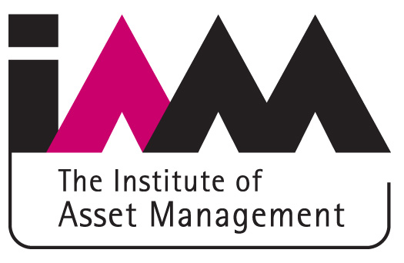

SSG Case Study Template

This template is to provide input to the IAM Subject Specific Guidelines Project. The aim is to capture individual and collective experience of operational and technical practices so that it can be shared and discussed. Suggested headings are shown in bold. Comments and suggestions are shown in italics.

Author:
Company represented:
Role: {asset owner/service provide/consultant/etc}
Sector: {electricity/water/gas/rail/road/air/petrochemical/other industrial}
Asset owner: {company name, if available}

Introduction

Description of assets in study
{Quantity, type and operational environment e.g. 500 electrical transformers}

When was the activity carried out?
{also, how long did it take?}

Why was the activity carried out?
{E.g. ageing assets, safety concerns, preparation of business case, corporate direction, regulatory requirement, environmental impact/sustainability etc
Was the approach used for prioritisation and selection of optimum courses of action/investment on programmes of work rather than single projects?}

Terminology
{Please provide definitions of terms used, where appropriate}

Description of activity

Methodology
{E.g. weighted scores, probability/consequence – please outline the approach used and why this was chosen over other methodologies.
Was the approach used for multiple types of asset and multiple types of risk?
How did the risks link to the business objectives?
Did the approach produce an overall cost/benefit?
Did the approach take account of the position over time (i.e. including asset deterioration)?
Was this a one off exercise or a rolling repeatable programme?}

References
{Is the methodology based on any published papers or reference material? Is it based on ISO55000? Is it based on International Infrastructure Management Manual? Is it based on HM Gov Orange & Green Book guidance? Please specify other sources if available}

Risk types
{What types of risk were considered? The Green Book lists: Availability risk, Business risk, Construction risk, Decant risk, Demand risk, Design risk, Economic risk, Environment risk, Funding risk, Legislative risk, Maintenance risk,
Occupancy, Operational risk, Planning risk, Policy risk, Procurement risk, Project intelligence risk, Reputational Risk, Residual Value risk, Technology risk, Volume risk – see Annex 5 of the Green Book for further details}

Risk management process
{How did the risk assessment used in the case study relate to the corporate risk register? (if at all). Was the process for determining levels of risk the same as corporate processes with the addition of financial measurement, or was another process used. If another process, was there a Governance mechanism in place to keep Risk Managers briefed? What was the relationship between risk evaluation and asset management planning?}

Tools used
{Software packages, spreadsheets, etc}

Costing
{What financial parameters were used? How were they determined? Were they historic (i.e. evidence-based), expert judgement or future estimates? Was there a link to actual budgets/costs and how did this work? Was cost of carbon included and if so what guidelines were followed? e.g. Shadow Price of Carbon or Market Value at time of case study.}

People
{Who was involved in the exercise? How many people (experts, stakeholders, neutral parties, etc)? Was the approach owned at Executive level?}

Evaluation

What was the main output of the activity?
{E.g. documented risks, secured funding, prioritised investment plan, improved safety, improved communication, etc. Also how did the risk subsequently appear in the financial plan, Net Weighted Value at departmental level, centralised risk fund, new capital investment etc}

Validation
{Was it possible to have the outputs validated? How was this done? Did anybody scrutinise the results? Were they borne out in practice? Was the approach subject to independent audit and continuous improvement and if yes how was this done?}

Outcome
{Was the activity successful (yes/no/partially)? Was the outcome as predicted? What embedded process or practice changed? In hindsight what would you do differently? Please elaborate if possible.}

